**Homework 12**

**Type in your score here 🡪 __23__ out of 23 points possible**

1. (5 points) Ponder/Reflect Exercise – Reflect on what you have learned from this portion of the class. Examples of what you can do are: a brief outline of material covered, insights you gained from class or personal study, or items you feel that you need to follow up or work on. (3-5 sentences)

I learned that a three way basic factorial is a really good way to experiment when you have 3 factors and want to know the interaction on them as well as the main effect. This sets up the possibility of doing more than a 3 way. It gets more complicated but it can be done.

2. A paper report on a study sponsored by CIFOR (Center for International Forestry Research) to evaluate the effectiveness of monitoring methods related to water and soil management. Part of the study considered soil runoff data from two catchment areas (area number 37 and 92) using runoff plots classified as “undisturbed/control” and “harvested” The runoff volume was calculated at each rainfall event, with the amount of rainfall serving as an additional factor at three levels (3.5-10 mm, 10-20 mm, and >20 mm). The data, consisting of four measurements per factor-level combination is in Soilrunoff.csv. Use Excel and R to complete the following parts using α=0.05.

Do the following.

1. Do a data decomposition and degrees of freedom of this analysis (6 points)

On excel sheet

(b) Complete an ANOVA table showing the sum of squares, degrees of freedom, F, and P-value for each of the main effects and all interactions using R. Also, check the requirement that the residuals are normal. Make Conclusions based off of the results (3 points)

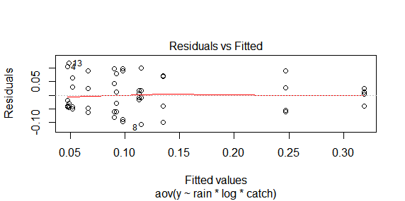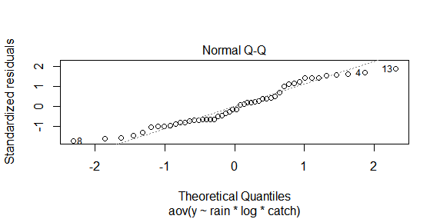

Looking at the residuals it looks like we have constant variance and the qqplot shows the data is normally distributed.

Analysis of Variance Table

Response: y

Df Sum Sq Mean Sq F value Pr(>F)

rain 2 0.140853 0.070426 13.3959 4.479e-05 ***

log 1 0.063003 0.063003 11.9838 0.001400 **

catch 1 0.001838 0.001838 0.3495 0.558063

rain:log 2 0.079943 0.039972 7.6031 0.001761 **

rain:catch 2 0.008774 0.004387 0.8344 0.442348

log:catch 1 0.006651 0.006651 1.2650 0.268149

rain:log:catch 2 0.003169 0.001585 0.3014 0.741635

Residuals 36 0.189263 0.005257

---

Signif. codes: 0 ‘***’ 0.001 ‘**’ 0.01 ‘*’ 0.05 ‘.’ 0.1 ‘ ’ 1

We can conclude that the factors of rain, log, and the interaction of rain and log are significant.

3. A machine is used to fill 5-gallon metal containers with soft drink syrup. The variable of interest is the amount of syrup loss due to frothing. Three factors are thought to influence frothing: the nozzle design (A), the filling speed (B), and the operating pressure (C). Three nozzles, three filling speeds, and three pressures are chosen with two replicates.

Using the soft drink syrup data, do the following.

1. Do a data decomposition and degrees of freedom of this analysis (6 points)

on excel sheet

(b) Complete an ANOVA table showing the sum of squares, degrees of freedom, F, and P-value for each of the main effects and all interactions using R. Also, check the requirement that the residuals are normal. Make Conclusions based off of the results (3 points)

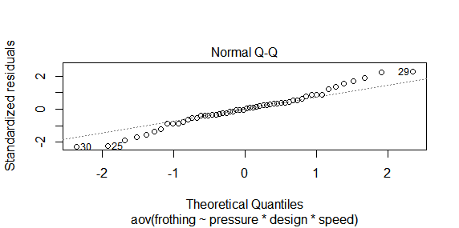

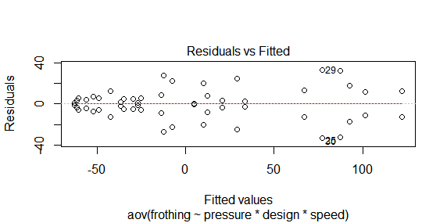

The data looks to be mostly normally distributed and the residuals plot makes it look like constant variance.

Analysis of Variance Table

Response: frothing

Df Sum Sq Mean Sq F value Pr(>F)

pressure 2 69105 34553 81.0145 3.893e-12 ***

design 2 994 497 1.1650 0.3271016

speed 2 61190 30595 71.7354 1.571e-11 ***

pressure:design 4 7514 1878 4.4044 0.0071866 **

pressure:speed 4 12854 3214 7.5348 0.0003269 ***

design:speed 4 6301 1575 3.6934 0.0159498 *

pressure:design:speed 8 4629 579 1.3566 0.2594959

Residuals 27 11516 427

---

Signif. codes: 0 ‘***’ 0.001 ‘**’ 0.01 ‘*’ 0.05 ‘.’ 0.1 ‘ ’ 1

We can conclude that pressure, speed and the interaction of pressure and speed, pressure and design, and speed and design are significant factors.